**The solution to road accidents by drowsiness and sleeping of the rider**

**Dr. Rohtash Dhiman**1**, Chirag**2**, Ramkumar**2**, Shubham Sharma**3

*1 Assistant Professor,Department of Electrical Engineering, DCRUST Murthal, Sonipat, Haryana,India*

*2 B.Tech, 3rd year,Department of Electrical Engineering, DCRUST Murthal, , Sonipat, Haryana,India*

*3 B.Tech, 3rd year,Department of Chemical Engineering, DCRUST Murthal, , Sonipat, Haryana,India*

**ABSTRACT:**

Every day around the world a fraction of road accidents took place due to the sleep or fatigue condition that ultimately results in deaths due to lack of communication gap between emergency services and the victim. The count of deaths every day in India only, equivalent to a jumbo jet crashing every day   This is the most unnoticeable cause of road accidents that can be solved effectively by an innovative approach by using the smart helmet. The smart helmet is equipped with a sleep detection system based upon the eye blinking monitoring system, that sends the signals to a microcontroller to activate an algorithm to wake up the rider. This ensures the safe recovery of the driver back to consciousness while driving.  The smart helmet works as a standalone device with built-in GPS and GSM technology for communication purposes during the accident. If the helmet is obtaining some break in continuous signals, then it will automatically generate an SOS service alert to the emergency number along with the location. This helmet can save the lives of people to a great extent providing the exact location for the emergency services to reach the victim quickly. Many priceless human lives can be saved by wearing this reasonable cost helmet that would eventually lead to the growth of our developing nation India. (GOI, n.d.)

1. INTRODUCTION

Traveling is an integral part of our day to day life and the means of transportation is developing day by day. But due to negligence of safety, this is causing a large number of accidents leading to death. Road traffic injuries in the last decade range in the top three in the leading causes of deaths in the developing world. Almost 13 lakh people lost their lives due to road accidents. In a survey, we found that from 2005-2016 a total no. of persons injured or killed vary between 5 lakhs to 6 lakhs which is approximate to no. of road accidents. Drowsiness while driving is an unwanted cause of road accidents and to solve this problem using modern technology a smart helmet is today’s requirement.(Agarwal, Singh, Singh, & Sahani, 2015)

That smart helmet will contain an eye blinking monitoring system along with an Arduino Uno microcontroller to take the right decision at the right time to detect the drowsiness of the rider and to make the rider conscious. In the scenario of an accident, an SOS alert SMS will be generated collaborated with the GPS coordinates of the rider location and send via GSM to an emergency contact who can access the location on Google Maps on the browser to provide early access of the emergency services to the casualty.(Satria, Yana, Munadi, & Syahreza, 2017)

1. EXISTING APPROACHES

Upgradation of helmet capabilities has attained the focus of many innovators in the world. We have found some of the measures to ensure the safety of the two-wheelers rider described below in detail.

The first approach was the development of smart low-profile helmet-mounted antenna to locate the movement of the individual in the “dead spots” for conventional antennas. The RF switching circuit was powered by a 3-V power supply for standalone operation. The project was a part of research conducted for the U.S. Army CECOM.(Tech, 2018)

Another approach was initiated to improve the safety of motorcyclists to ensure that the motorcycle will only start when the rider is wearing the helmet and the ignition goes off as soon the helmet is removed. The helmet establishes a connection with the vehicle via Radio Frequency (RF) at 434 MHz This way it was a mandatory gear that the rider should carry to commute on the two-wheelerss.(Agarwal et al., 2015)

1. PROPOSED IMPLEMENTATION

*Block Diagram*

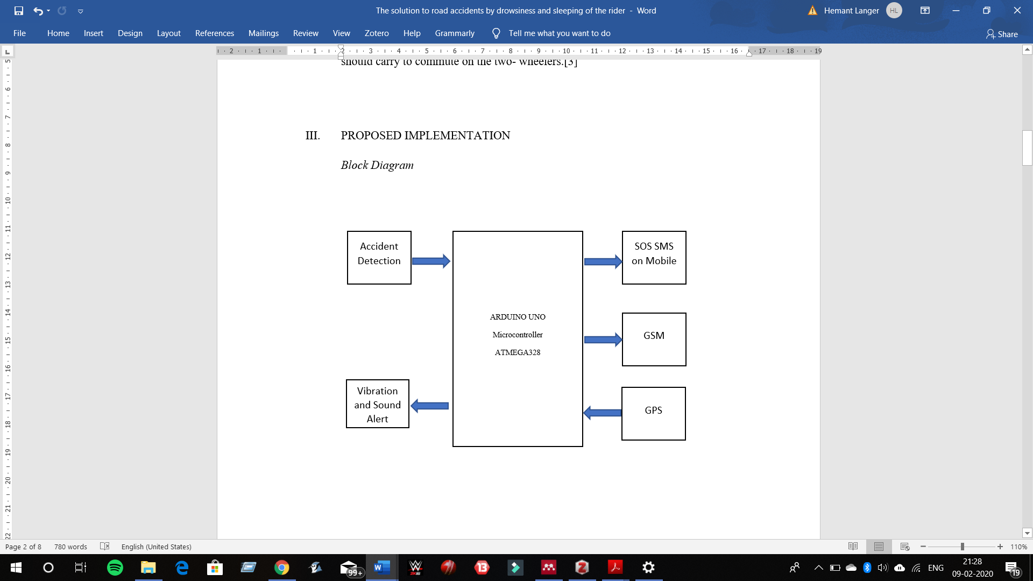

***Fig1: Flow of information***

The system is working on Arduino®. Infrared (IR) sensor is used whose output values will contain either ‘0’ or ‘1’. The output of the IR sensor is the input to the ATMEGA 328 microcontroller of the Arduino®. The response of IR output as per the microcontroller will direct the input to the vibrating motor and buzzer. If the input signal is restored back to normal, the microcontroller will abort the working of vibrating motor and buzzer. (Technology & Khanal, 2014)

When the output of the IR sensor is high for a significant time, control goes to the GPS to obtain the coordinates of the location. GSM is connected to the microcontroller to receive the output of the GPS as an input in terms of latitude and longitude to generate an SOS message. Data is sent to the mobile phone through the GSM Module. Using the latitudes and longitude coordinates in the Google Maps the SMS receiver will be directed to the exact location of the accident zone.

1. HARDWARE USED

In this prototype, the system used the Arduino Uno microcontroller board based on the Microchip ATmega328P microcontroller. Arduino operates on a voltage of 5 Volts. There are 6 Analog Pins (0-5) input pins, 14 digital input/output pins (6 pins as PWM) a USB connection, 32kb flash memory, 16 MHz clock speed, and a reset button. Arduino Uno is shown in Fig 2.(Palanisamy, Hiteshkumar, Sahasrabuddhe, & Puranik, 2019)

***Fig2: Arduino Uno*** 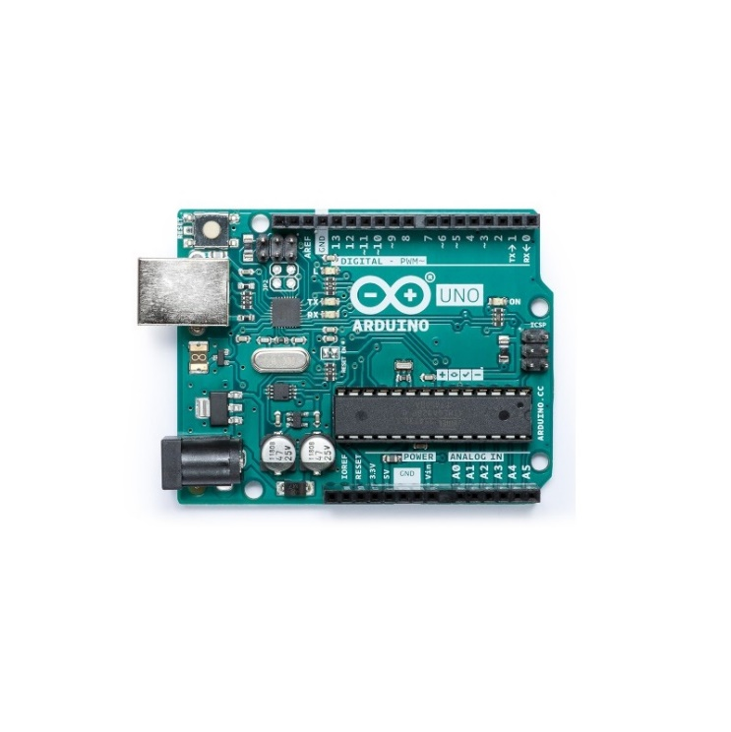

GSM Sim900A module supplies the intermediate microcontroller in the procedure of sending SMS. GSM Sim900A module operates on a single-chip processor. LPC2148 single-chip processor is used. GSM Sim900 provides features such as SMS and voice data sending.(Kavya, 2019)

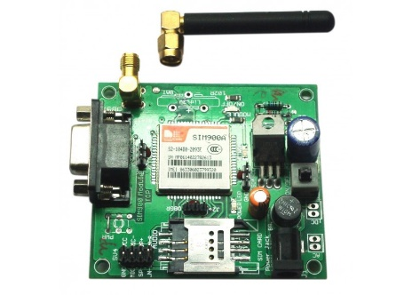

***Fig3: Sim 900 A Module***

The GPS U-Blox 6m module is a sort of independent GPS receivers providing high performance as a positioning device. GPS U-Blox 6m module is perfect for battery-driven devices with limited cost due to its optimized architecture, power, and memory. The module supports 50 channels of positioning engines.(Sheet, n.d.)

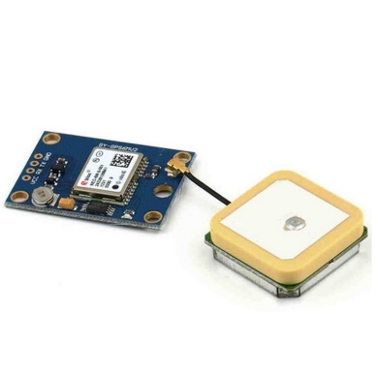

***Fig4: GPS U-Blox***

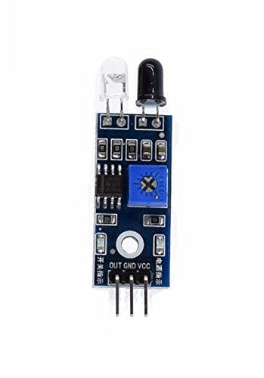An IR sensor is a device that detects IR radiation falling on it. Its detection distance is 2-30cm and the detection range is 35°. IR sensor consists of a transmitter and a receiver. The IR LED emits IR radiation, the reception of which by a photodiode dictates the output of the sensor.(Ajmera, 2017)

***Fig5: Infrared Sensor***

The smart helmet comprises of all the above-depicted devices. The smart helmet is a stand-alone device. Vehicle condition and rider’s mobile doesn't affect the working of the smart helmet in any form. The smart helmet is battery driven having 2600 mAh Li-Ion battery with battery backup up to 1 week. Smart helmet supports Type - B charging port. Ready to works as it is worn on the head. (Vidhya & Kasiselvanathan, 2018)

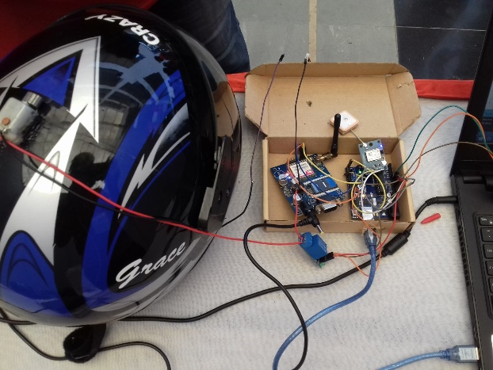

***Fig.6 Prototype of Smart Helmet***

1. RESULT AND DISCUSSION

***Flowchart:-***

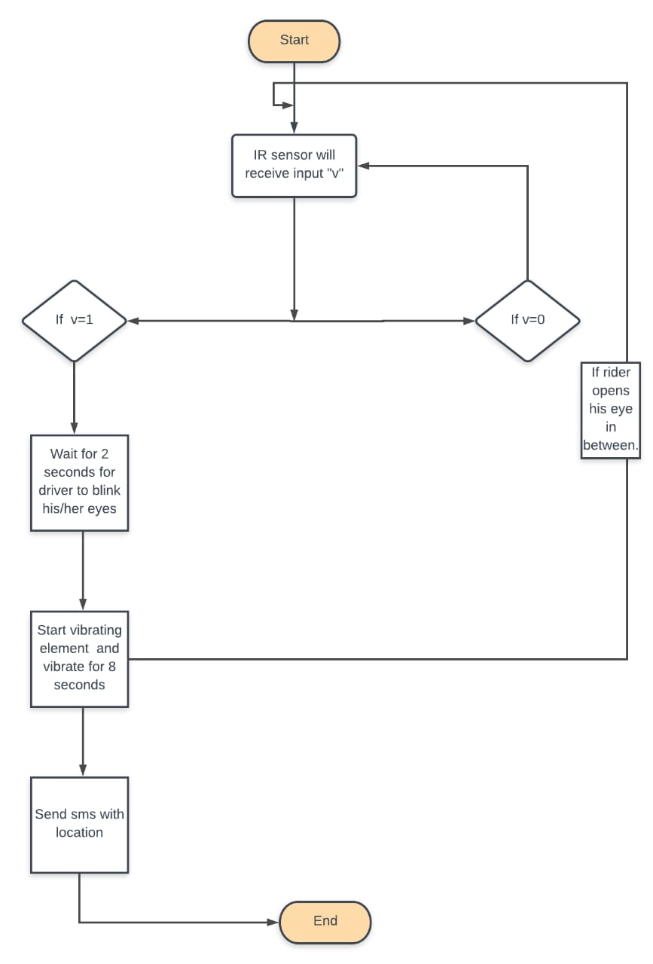

***Working:-***

The rider wears the helmet to activate it. The IR sensor is set in the line of sight of the pupil of the eye. The opening of the eye’s black pupil is acting as an absorber of infrared light sent through the transmitter and in case of eye blinking that light is being reflected by the eyelid. Blinking of the eye is an involuntary periodic action. Normally eyes blink 15 times in a minute. In the case of drowsiness, the rider’s eye will remain closed for more than 2 seconds continuously. The Microcontroller will respond to IR output to start the vibrating motor and buzzer. If the rider restored back to the normal condition of eye blinking. The ongoing processes will be restored back to default.

Until we lost our signal the device will work as a simple helmet, once we lost our signal for more than 6 seconds in a row this will confirm that something wrong had happened with the rider and he /she needs some help. The output of the GPS will be taken as input by the microcontroller. The SOS SMS will be generated as in Fig.

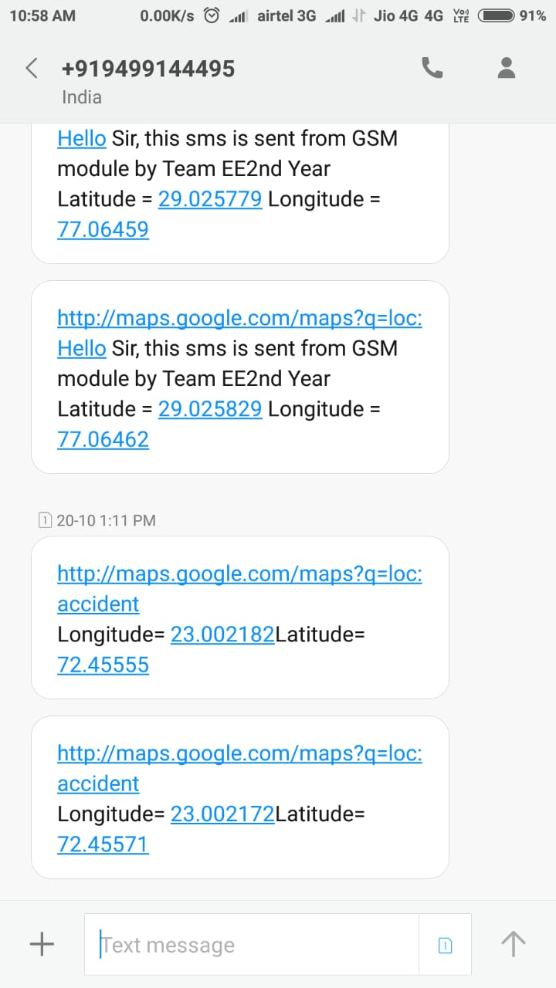

**Fig** SOS Message generated by Smart Helmet

Upon placing the coordinates provides on Google Maps, the exact Real-time location of the helmet is depicted.

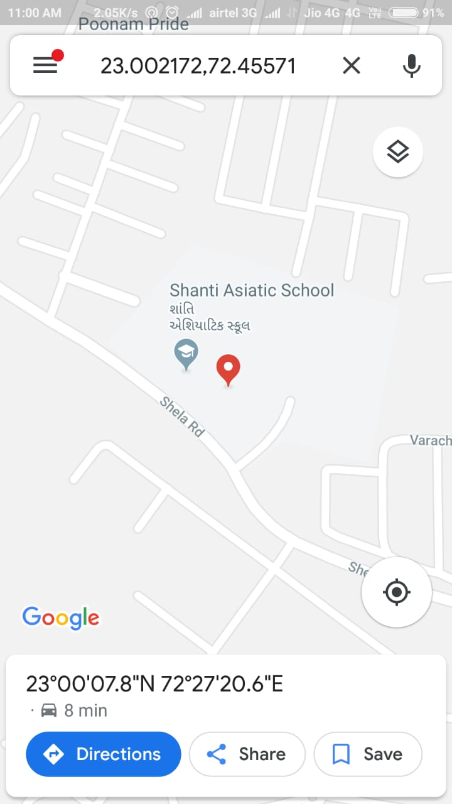

**Fig. Real-Time location of Smart Helmet**

1. CONCLUSION

For the developing country like India where the most commonly used commutable means of transportation are two-wheelers due to the economic factor taken into consideration. In case of death in a road accident due to lack of proper communication of exact accident spot over a long stretch of highways or expressways, till the time ambulance reaches the casualty the health condition worsens and eventually leads to death. Death of a single earning the person will cause turn his whole family a liability over the economic growth of the country. We have designed this helmet to prevent any such road accidents due to the drowsiness of the riders and in case of an accident, the emergency services could follow the exact coordinates for the quick response and hence a priceless life is saved that will turn out to be a large factor for the country that needs human resources to build a stronger nation tomorrow.(K.rso, n.d.)

BIBLOGRAPHY:

Agarwal, N., Singh, A. K., Singh, P. P., & Sahani, R. (2015). Smart helmet, 19–22.

Ajmera, P. (2017). A Review Paper on Infrared sensor, *5*(23), 1–3.

GOI, M. (n.d.). ROAD ACCIDENTS IN INDIA – 2018.

K.rso. (n.d.). Introduction to Road Safety, 1–62.

Kavya, G. (2019). Design of FPGA based NIOS-II Soft Core Processor for a wearable Tele Cardiac Design of FPGA based NIOS-II Soft Core Processor for a wearable Tele Cardiac System, (December 2017). https://doi.org/10.29294/IJASE.4.2.2017.566-570

Palanisamy, R., Hiteshkumar, M. K., Sahasrabuddhe, R., & Puranik, J. A. (2019). IoT Based Patient Monitoring System, (2), 2559–2564. https://doi.org/10.35940/ijrte.B1304.0982S1119

Satria, D., Yana, S., Munadi, R., & Syahreza, S. (2017). Prototype of Google Maps-Based Flood Monitoring System Using Arduino and GSM Module, 4–7.

Sheet, D. (n.d.). NEO-6.

Tech, I. V. S. M. (2018). Implementation of Smart Helmet, *6*(13), 1–4.

Technology, I., & Khanal, L. P. (2014). OBSTACLE-AVOIDING ROBOT.

Vidhya, K., & Kasiselvanathan, M. (2018). Smart Helmet and Bike System, (4), 2–5.